PENETRATION POWER OF RADIATION

Aim: To measure the relative penetrating abilities of radioactive sources.

Hypothesis:

Method:

1. Set up the following apparatus, without the source in place.

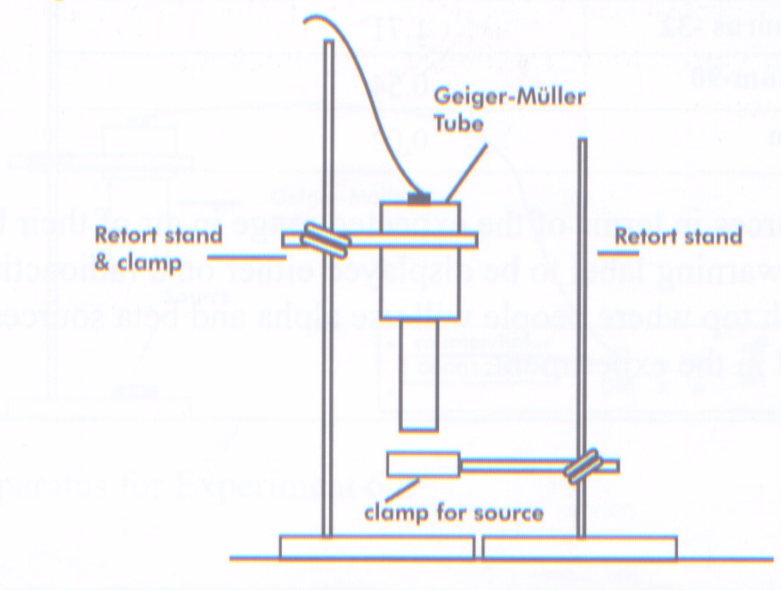

2. Place the Americium-241 source (alpha source) under the Geiger counter and measure the count rate for 60 seconds at a distance of 1.0 cm. Record your observations in a table.

3. Place a piece of paper between the source and Geiger counter, and measure the count rate. Record your observations.

4. Without moving anything but the paper, repeat the procedure for aluminium and lead.
Record your observations.

5. Repeat the above procedure for Strontium-90 source (beta source) and Cobalt-60
(gamma source).

Results:

Alpha Source
Material | Count Rate (per minute)
air
paper
aluminium
lead
Beta Source
Material | Count Rate (per minute)
air
paper
aluminium
lead

Gamma Source
Material | Count Rate (per minute)
air
paper
aluminium
lead

Discussion:

Conclusion:

